Ode to Alresford
A child in Holland - dreaming of the hills
in which ploughed fields rise up to meet
proud woods parading on the ridge,
stooping and rising with defiant ease;
an ancient farmhouse hidden in the
shade of comforting, protective trees;
a sandy lane losing its way, secluded
among hedgerows through the fields;
a friendly unexpected town, surrounded by
green hills and clear fresh water springs;
a church with bells; a station in the age of steam;
Alresford in Hampshire — fulfilment of my dream.
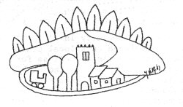
By kind permission of Jane Newble-de Graaf

